Exercise 2

Name: Matt Josel Ouano Date: ___________________

Requirements:

Storage: 50 GB

2 logical partitions: Disk 0: 30GB

Disk 1: 20GB

Memory: 4GB

OS: Ubuntu 22.10 64bit

User accounts: (Create two user accounts) The first account is for you with your complete details and the 2nd account is for a guest user.

Install Ubuntu OS (guide on another file) and answer/complete the following questions:

1. What is the purpose of the Ubuntu installer's "Try Ubuntu" option?

The purpose of the “try ubuntu” option is so that the user will be able to try out the Linux distro in their device. Without having to install the OS in their system with the use of a bootable device, this is useful when the user just wants to tryout the distro if it works well with their device and if it is to their liking.

2. How can you partition a hard disk during the Ubuntu OS installation process?

I can partition the hard disk during the Ubuntu OS installation progress on the disk partition step of the installation. The “something else” option will be selected then continue. After that the storage allotted for the system will show and then just right click and select new partition table then we will click on the new created partition table which is labeled as “free space”. Next will be to add the partition or create, the specified file size should be inputted and the logical drive must be selected. One most important step is to make sure to configure on the mount point the “/” to specify it as the root home directory as ubuntu would not install if this is not selected on the mount point. After that the partition will be then successfully created.

3. How can you install additional software packages after Ubuntu OS installation?

I can add additional software packages through Ubuntu using their built in “Ubuntu software” or I could also browse through the web for specific software packages depending on my need and most of it would be installed through terminal using the code provided for the software package. The internet would be needed as it would be downloaded through it and using “sudo” for packages that needs administrator privileges to be installed.

4. Screenshot of the login screen with the two user accounts

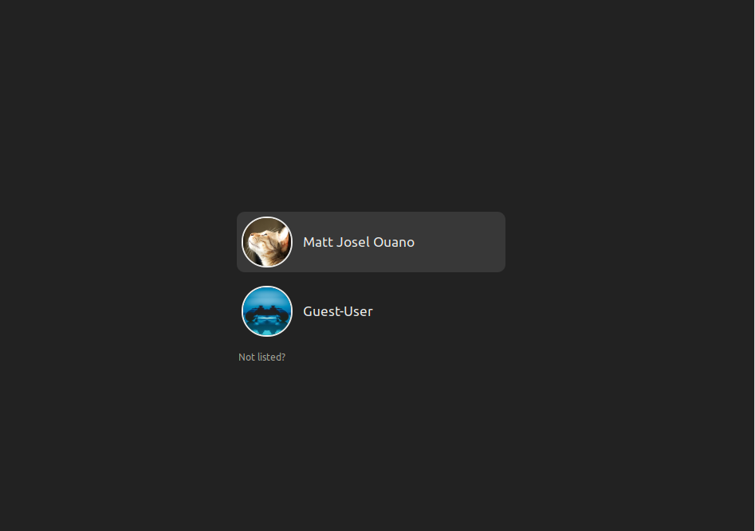

5. Screenshot of the logical drives

